**CS 487 DATA SECURITY**

**HOP10 – Infrastructure as Code (IaC)**

2/25/2021 Developed by Mary Oh

Center for Cybersecurity Innovation (C4CYI) @City University of Seattle (CityU)

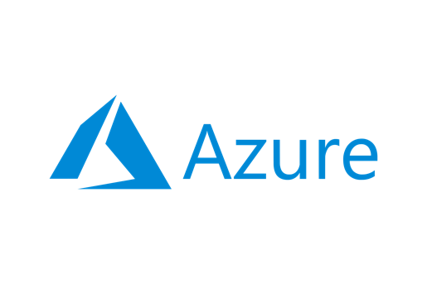

**Before You Start**

* Version numbers may not match with the most current version at the time of writing. If given the option to choose between stable release (long-term support) or most recent, please choose the stable release rather than beta-testing version.
* This tutorial targets Windows users and MacOS users.
* There might be subtle discrepancies along the steps. Please use your best judgement while going through this cookbook style tutorial to complete each step.
* For your working directory, use your course number. This tutorial may use a different course number as an example.
* The directory path shown in screenshots may be different from yours.
* If you are not sure what to do or confused with any steps:
  + Consult the resources listed below.
  + If you cannot solve the problem after a few tries, ask a TA for help.

**Learning Outcomes**

* To deploy Infrastructure as a Code

**Resources**

* Microsoft Azure - [https://azure.microsoft.com/](https://azure.microsoft.com/en-us/overview/what-is-azure/?&ef_id=Cj0KCQiAlsv_BRDtARIsAHMGVSac9cd8I7htfl0EVYTYDUBxYJ7mEqQ6dB5bRem2ziaBp-j1Di4wui8aAivlEALw_wcB:G:s&OCID=AID2100131_SEM_Cj0KCQiAlsv_BRDtARIsAHMGVSac9cd8I7htfl0EVYTYDUBxYJ7mEqQ6dB5bRem2ziaBp-j1Di4wui8aAivlEALw_wcB:G:s&gclid=Cj0KCQiAlsv_BRDtARIsAHMGVSac9cd8I7htfl0EVYTYDUBxYJ7mEqQ6dB5bRem2ziaBp-j1Di4wui8aAivlEALw_wcB)

**What is Infrastructure as Code (IaC)?**

Infrastructure as Code is the management of infrastructure such as networks, virtual machines, load balancers, and connection topology, in a descriptive model, using source code. With IaC, users can make changes to the environment description and version of the configuration model, typically in well-documented code formats such as JSON. If the user requires to make changes, they edit the source, not the target. Manual configuration of the environment is avoided, and consistency is enforced by representing the desired state of the environment via code. Infrastructure deployments with IaC are repeatable and prevent runtime issues caused by configuration drift or missing dependencies.

**Deploy IaC in single JSON file**

Throughout this course, you were supplied with the ARM template for deployment of different infrastructure or resources on Azure. For your final HOP, deploy at least three resources of your choice using single deployment JSON file, you may or may not choose to use parameters file depending on your preference. For your submission, include the json file/s and screenshots on your write-up.